**A DL-Based Optimisation for Renewable Energy Mix at Record Low Cost**

**KING ABDULAZIZ UNIVERSITY**

**University representative**

Dr. Adil Khadidos

[akhadidos@kau.edu.sa](mailto:akhadidos@kau.edu.sa)

**Group Name**

FORWARD-LOOKING

**Group Members**

Abrar Alkhamisi

Junaid Qurashi

Osama Younis

Ulaa Alhaddad

Zaakki Luthufi

**Supervisor Name**

Prof. Maher Khemakhem

**Table of Contents**

MEMBERS BIO 2

INTRODUCTION 3

CHALLENGE AREA 4

**Energy Challenge** 4

RESEARCH METHODOLOGY 5

PROPOSED IDEA 6

OBJECTIVES OF THE PROJECT 7

**Core objectives:** 7

**Secondary Objectives:** 7

**Tertiary Objectives:** 7

SOLUTION 7

**Data Collection** 7

**Machine/Deep Learning Model** 11

**Dashboard** 21

**Application** 26

SIGNIFICANCE 28

RISK & OBSTACLES 29

Related Work 30

CONCLUSION 31

Q & A 32

REFERENCES 33

# MEMBERS BIO

**Abrar Alkhamisi**

Abrar Omar Alkhamisi is currently a Ph.D. student at the Computer Science Department, King Abdulaziz University, Saudi Arabia. She received an M.S degree and B.s degree in Information Technology from King Abdul Aziz University. Her research interests include Networking Security, Big Data, Ontologies , Artificial Intelligence, Deep Learning, Block Chain, Internet of Things, Mobile Ad hoc Networks, Routing Protocols and Smart Cities.

**Junaid Qurashi**

Junaid Mohammad Qurashi is currently pursuing his PhD at King Abdulaziz University, Jeddah, Saudi Arabia. He completed his Master’s degree from International Islamic University Malaysia and his Bachelors from Kashmir University, Jammu & Kashmir, India. His interests are in the field of Cybersecurity, Resilience, Sensor-Fusion, Artificial Intelligence, Cloud Computing, Machine Learning and Deep Learning.

**Osama Younis**

Osama Hamdy Younis is experienced Systems Analyst with a history of working in the Information Technology industry and academic research. Interested in Software Engineering, AI, Cloud Computing, Blockchain and Android Apps. He has professional skills in IT strategic KPIs, with a Master's degree in Computer Science and currently pursuing a PhD from King Abdulaziz University.

**Ulaa Alhaddad**

Ulaa Alawi Alhaddad is a Ph.D. Candidate student in Computer Science at King Abdulaziz University, Jeddah Saudi Arabia. She obtained her M.S degree from King Abdul Aziz University and B.S from King Faisal University. Her research interests are in Wireless Networking, Internet of Things (IoT), Networking Security, Big Data, Smart Cities, Artificial Intelligence (AI), Deep Learning (DL), Machine Learning (ML) High Performance Computing (HPC).

**Zaakki Luthufi**

Zaakki Ahamed is currently a Ph.D. student in the Department of Information Technology at FCIT, King Abdulaziz University, Jeddah. He obtained his Master’s degree from the University of Peradeniya, Sri Lanka. A hands-on developer with proficiency in many development tools and environments such as Python, R, UNIX, Java, and SQL. His interests are in the fields of Data Engineering, Machine Learning, Deep learning model, HPC systems, and Cloud computing platforms.

# INTRODUCTION

NEOM, a city envisioned to be futuristic in its all essence, would be completely driven by renewable sources of energy. Although, NEOM is blessed with potential of being a solar and wind energy hub, forecasting and prediction of energy generated, and its consumption will be fundamental in realising a city that delivers the energy demands while sustaining its dependence on greener energy sources. Also, artificial intelligence-based energy data management and monitoring system would be needed, as these will pave a way to create innovative solutions and techniques to reduce energy consumption while optimizing energy generation according to energy demand. Hence, we propose to build an ML model capable of accurately forecasting solar and wind power generation that takes into account NEOM's unique weather patterns and created a few prototype interactive dashboards to display the data. Also, our model intends to forecast energy demand of NEOM with objective to optimise the utilisation and hence reducing the energy cost in return. Primarily, we will predict future solar and wind power generation at NEOM by using ML techniques as a function of the weather data along with the history of solar and wind power generation. Further, we can generate a new prediction wind power and solar power based on parameters irrespective of day after training historical data on our model. Our mobile app prototype will allow users at NEOM to interact with the weather and mixed energy predictions and to get notifications about important upcoming changes to either weather or solar or both energy predictions by display predictions of future solar and wind power generation. In the same way, we can predict the future electricity demand at NEOM. Moreover, in future work we can add more features at our mobile app such as send an alert to the users if the energy consumption exceeds a certain threshold and if there is no response from the user, the system will directly turn off the energy supply and shows battery mode.

# CHALLENGE AREA

## **Energy Challenge**

As recognized, fossil fuels won’t be able to satisfy our energy requirements in the future because of the growing populations resulting in excess global energy demands. Due to the increase in energy consumption, carbon emissions have been increased too. Renewable energy is a better alternative to fossil fuels. The leading sources of renewable energy are solar and wind; and the power generation largely depends on the weather which is a significant challenge due to the high rate of the unpredictability of the weather. NEOM’s area blessed with a climate that provides a unique solar and wind profile and through competitively priced renewable energy, we can record low cost for energy consumption and build new industries leads to diversify the Saudi Arabian economy and reduce dependence on oil revenues which is a key element in Vision 2030.

Figure 1: NEOM Area

# RESEARCH METHODOLOGY

Figure 2: Methodology

# PROPOSED IDEA

Figure 3: Idea flowchart

# OBJECTIVES OF THE PROJECT

The underlined form the core objectives of our project followed by secondary and tertiary objectives:

## **Core objectives:**

1. Use reliable weather data for NEOM region.
2. Predict Wind Energy generation at NEOM.
3. Predict Solar Energy generation at NEOM.
4. Predict Consumption within NEOM city
5. Calculate / Predict future demand / supply.

## **Secondary Objectives:**

5. Implement a mechanism to consider alternative sources to cover the demand/supply gap.

6. Implement a dashboard to view all data.

## **Tertiary Objectives:**

8. Implement mobile app.

# SOLUTION

## **Data Collection**

### NEOM Solar:

### Following steps were taken to collect the data on Solar Energy for NEOM:

* Use the data from the source - Renewable Resource Atlas (<https://rratlas.energy.gov.sa/>)
* Find out locations of Solar panel data collection centers.
* Filter out and find locations closer to the NEOM area. Create a map detailing levels in terms of closeness to NEOM
* Rank the stations based on close proximity to NEOM as Closest, Level 1, Level 2 and Level 3 stations.
* Combine the data from stations together based on required data points to train Neural Network.
* Calculate Solar energy generated.

Figure 4: NEOM solar stations

### NEOM Wind:

Following steps were taken to collect the data on Wind Energy for NEOM:

* Use data from the source - Renewable Resource Atlas (<https://rratlas.energy.gov.sa/>)
* Filtered the data for the stations closer to NEOM.
* Normalization and Null values were handled.
* Mapped the location to the NEOM area.
* 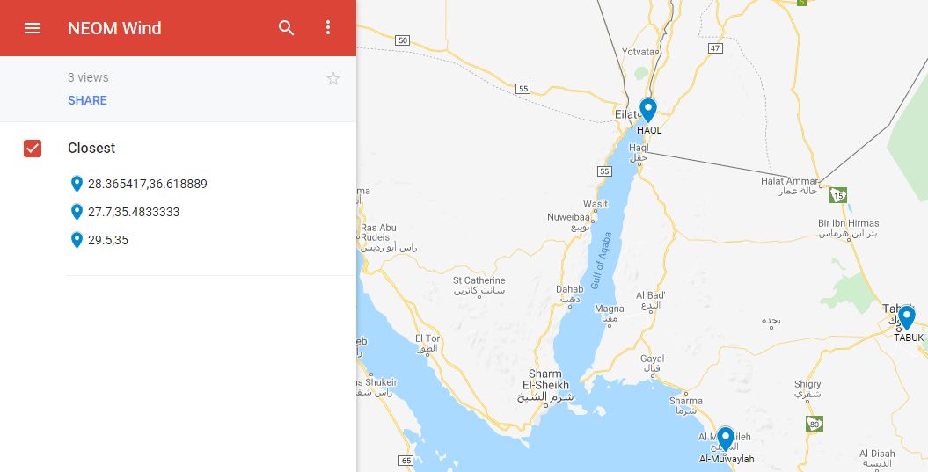Calculate Wind energy generated for each station

Figure 5: NEOM wind stations

### 

### NEOM Consumption:

Following steps were taken to collect the data on Consumption Data that could be related to the demands of city like that of NEOM:

* Use data from the source:

( <https://data.gov.au/data/dataset/smart-grid-smart-city-customer-trial-data>)

* Gain knowledge about the dataset (use UNIX commands, MySQL, Pandas, Dask for processing)

**Formulation**:

|  |  |  |
| --- | --- | --- |
| Wind Energy | Solar Energy | Consumption Energy |
| * Fix the date notations to suit our purpose * Reduce ambiguity in location coordinates * Remove columns not directly related to our purpose * Handle outlier and invalid data * Calculating wind Energy Output: * Step 1 - Calculate Air density with the available columns (Air pressure, Dew point, Air temperature) Step 2 - Calculate the power output in Kilowatts of a wind turbine based on the available column values using formula P = π/2 * r² * v³ * ρ * η | Energy output (kWh/month) = $Solar Array Area \left(m2\right)×Conversion Efficiency ×$ Solar Radiation for the month (kWh/m2/day)  Calculating Solar Energy Output:   * **Step 1** - Photovoltaic array area - 0.9906 m * 1.9812 m = 1.9625 m2 (62,000 of this = 15Mw) * **Step 2** - Tilt of the array (25.7 degrees based on POWER_SinglePoint_Climatology_028d18N_034d85E_44f96c9a.csv) * **Step 3** - Determine annual radiation (2361.55 kWh/m2 per year) * **Step 4** - Find conversion efficiency (16.3%) * Capacity (kW DC) = (1 kW/m2) x (1.9625 m2) x 16.3% = 0.3198875 kW DC * Capacity (kW AC) = 0.3198875 kW x 95% = 0.303893125 kW AC * **Step 5** - Effect of temperature (At standard 25- degree temperature, efficiency is 16.3%) | * Since KSA doesn't have any proper SMART city data, so we can use data from a similar smart city setup for our purposes. * The aggregate consumption of all users on a per-day basis * Contains data for 13,735 customers it has 882 rows of data. |

Table 1: Formulation of Wind, Solar and Consumption Energy.

## **Machine/Deep Learning Model**

In Artificial Neural Network-based system (ANN), the neurons are linked by weighted activation where the network is modeled by an input layer related to the sources of information (input data), the hidden layer constructed of several neurons, and an output layer comprised of information transferred from the network to the signal output. As shown below in figure 6 the Neural Network architecture is made up of 1 input layer, 2 hidden layers and 1 output layer. The input layer has 4 neurons while the hidden layers have 2000 and 1000 layers respectively.

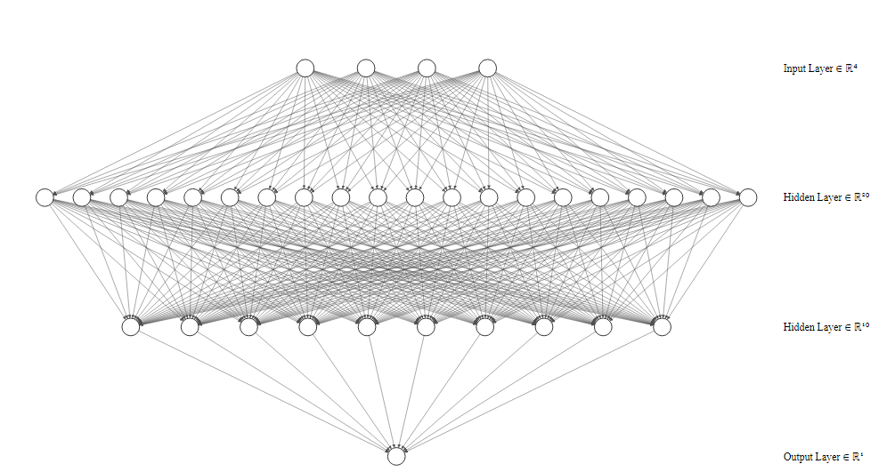

Figure 6: Neural Network Architecture

### Long Short-Term Memory for Time Series Prediction

Long Short-Term Memory networks, usually just called “LSTMs”, are a special RNNs that are suitable for learning long-term dependencies**.**

|  |  |  |
| --- | --- | --- |
| Wind Energy | Solar Energy | Consumption Energy |
| * In dataset # 40375099999 station constitutes 99%, there was very little data so other stations, training a model for them is not feasible. So splitting the dataset belonging to the station # 40375099999, into a train (90%) and test set (10%). * Gathering columns (parameters) for training: 1st col: wind_speed_rate 2nd col: Sin of wind-direction 3rd col: Cos of wind-direction (In degrees) 4th col: Air density | * We trained a 3 layer Including input and output layer Neural-network, where the neural network predicts the power output given: * Air_temperature. * wind_speed_at_3m. * DHI (Wh/m2). * DHI Uncertainty (Wh/m2). * DNI (Wh/m2). * DNI Uncertainty (Wh/m2). * GHI (Wh/m2). * GHI Uncertainty (Wh/m2). * Relative Humidity (%). * Relative Humidity Uncertainty (%). * Barometric Pressure (mB (hPa equiv)). * Barometric Pressure Uncertainty (mB (hPa equiv). * We have done 7-fold Cross-validation (CV) i.e. one of the techniques used to test the effectiveness of a machine learning models, it is also a resampling procedure used to evaluate a model if we have a limited data. * We split the data into 7 parts (618/7), 618 approximately 80 samples. So, for every 7 runs, 530 samples will be used as train and 88 will be used as the test. | Time series analysis of power consumption we use Walk-forward algorithm for validation:   * It is a method of validating a time series model suited for less size dataset. * It initially splits the dataset into 2 parts, training data, and test data. * The model initially trains itself based on the training data. * For testing, each testing instance from the test set is taken for prediction, however, after prediction for that instance is done, the entire model is refit again by including this particular test instance into the original train set and continued iteratively for other instances. * For time series analysis we used XGBoost Algorithm as explained in the consumption prediction section. |

Table 2: Steps of predicting Wind, Solar and Consumption

### Wind Prediction Model Results:

Performance of the model in terms of MAPE and MAE for non-zero and zero power_out_kw values respectively .We consider non-zero and zero power_out_kw separately because, calculating MAPE when a target columns has zero(s) is not advisable, therefore, we've considered two different evaluation schemes for both zero and non-zero power_out_kw values test . MAE for zero power_out_kw: 0.0 Kw. MAPE for non-zero power_out_kw: 7.232416251967087 %.

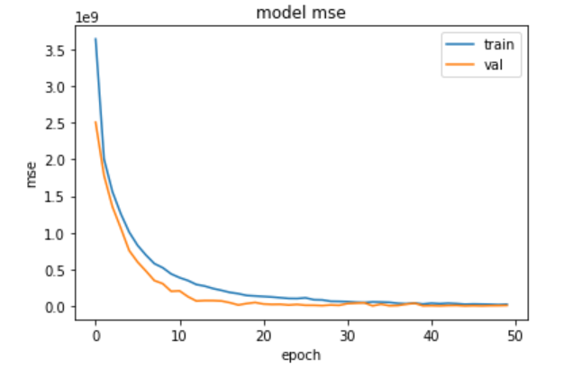

Figure 7: Wind Prediction Result

The fact that the MSE is dropping with the epochs is a good sign. It shows that there are less extreme/outlier data points. The model is only off by a small factor which is acceptable.

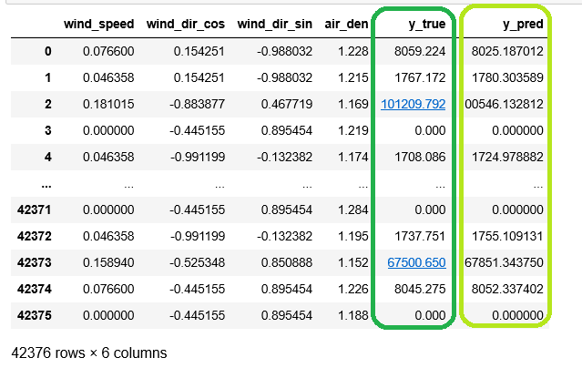

Table 3: Wind Prediction Model Results

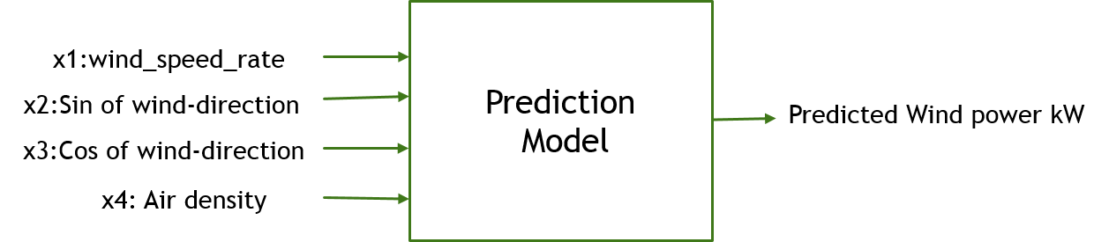

Figure 8: Wind power prediction model

### Solar Prediction Model Results:

Figure 9: Solar Prediction Model MAE Result

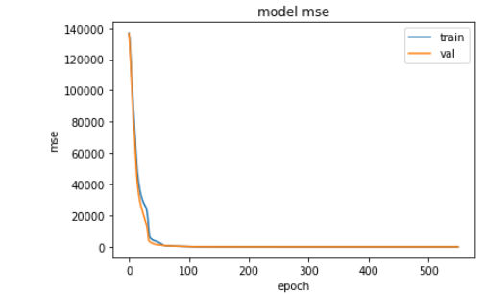We have done 7-fold Cross validation. we see there in 5 out of 7 evaluations our neural network has loss(val_mse) less than 5 which is very good. Nevertheless, we see that evaluations model 6 has the very least val_mse, so we use that model as the final model for further prediction purposes. The evaluation results: MAE: 0.8148574829101562 and MAPE: 0.22775055468082428.

Figure 10: Solar Prediction Model MSE Result

Same as the results of the Wind Prediction Model, the MSE here is dropping with the epochs which means there are less extreme/outlier data points. The model is only off by an acceptable small factor.

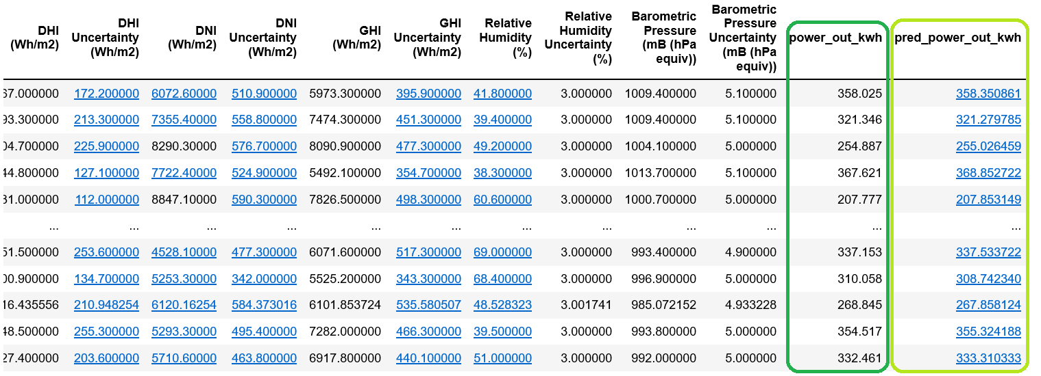

Table 4: Solar Prediction Model Results

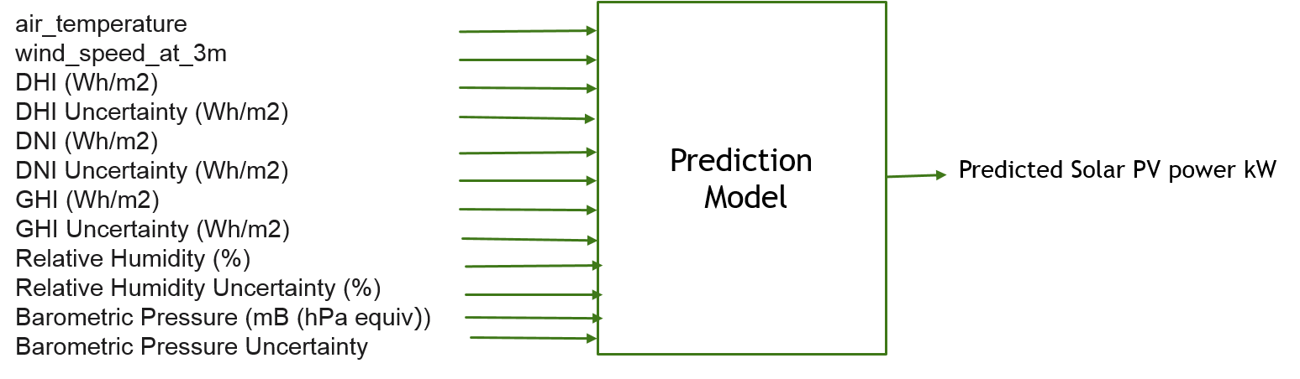

Figure 11: Solar power prediction model

Comparison of Accuracy Results of Related Researches works in solar energy production:

Table 5: Comparison of Accuracy Results of Related Researches works

|  |  |  |  |  |  |
| --- | --- | --- | --- | --- | --- |
| Reference No. | Location | Latitude/longitude | ANN/Solar Method | Variables | Finding |
| (T. Khatib, A. Mohamed, M. Mahmoud 2012) | Malaysia  Kuala Lampur  Alor Setar  Johor Bharu  Kuching Ipoh | 3.1390N/01.6869E  6.1248N/  100.3678E  1.4927N/  103.7414E  1.6077N/  110.3785E  4.5975N/  101.0901E | MLPFF/GSR | SR | MAPE: 0.592  RMSE: 7.96  MBE: 0.0146 |
| (Kadirgama, Amirruddin, and Bakar 2014) | Malaysia | 4.2105N/  101.9758E | SLP-QPA/GSR | TM, RH  WS, PRE TIME | MAPE: 0.774  R2:0.989  MBE: 0.026 |
| (Kalani, Sardarabadi, and Passandideh-Fard 2017) | Iran | 29.4963N/  60.8629E | MLP-LM, RBF, ANFIS/  GSR | TM, SR, RH  SH, Rain. | MAPE: 0.5054 R2:0.9906  RMSE: 0.2562 |

Global Solar Radiation (GSR), Ambient Temperature (TM), Solar Radiation (SR), Relative Humidity (RH), Sunshine Hours (SH), Wind Speed (WS), Pressure (PRE). Multi-Layer Perceptron Feed Forward (MLPFF), single layer perceptron (SLP), (QPA) Quick Propagation Algorithm, (MLP) Multi-Layer Perception, (LM) Levenberg-Marquardt, (RBF) Radial Basis Function, (ANFIS) Adaptive Neuro Fuzzy Inference System.

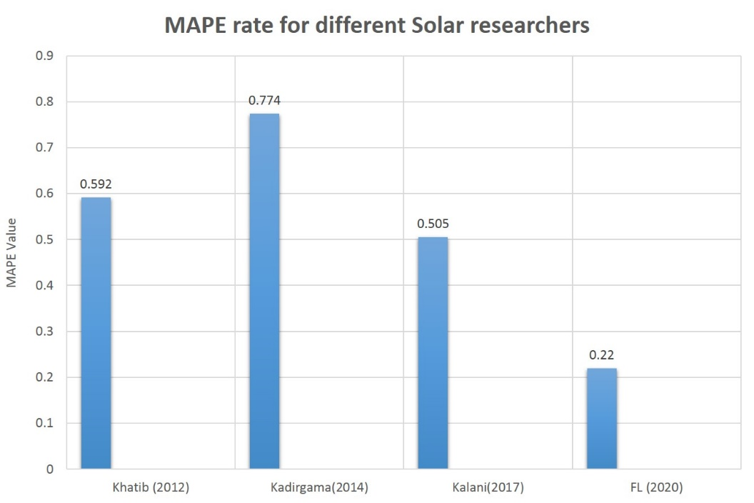

Figure 12: MAPE rate for previous researches with our result using Forward Looking (FL) solution

### Consumption Prediction Model Results

In this part of our project we use XGBoost Algorithm (Jason Brownlee 2020) for time series analysis it is called ‘Extreme Gradient Boosting’. XGBoost is not just made of a single model, it's am ensemble of models, with each model correcting the errors made by the previous model, so together they perform fantastically good. It is a perfect combination of software and hardware optimization techniques to get superior results using fewer computing resources in the shortest amount of time. Moreover, it is optimized gradient Boosting algorithm through parallel processing, tree-pruning, handling missing value and regularization to avoid overfitting/bias.

The advantages of XGBoost Algorithm as the following:

* Can be used to solve regression, classification, and prediction problems.
* Portability: Runs smoothly on Windows, Linux, and OS X.
* Supports major programming languages including C++, Python, R and Java.
* Integration: Supports AWS, Azure and other ecosystems.
* Parallelization of tree construction using all of your CPU cores during training.

We calculated the gradient of the loss function defined for each output produced by the model, now this set of gradients will act as the target variable for the next model. The second model will learn this and will output it's predicted gradient for each input, so we update our final model based on it accommodating the gradient, so the same process of finding gradient is done again for the updated model's output and the third model learns the mapping between input and gradient and so on the process continues until stopping criteria.

We also use Walk forward (Brownlee 2019) for validation which is one among other validation methods used for Time Series problem. It initially splits the dataset into 2 train + test, and the model initially trains on the training dataset. And for each observation in test set: 1: The trained model is used to predict a value for it, and its output is compared with existing value to compute error 2: Next this observation is included in the existing training dataset and the model is retrained again. 3: Now this retrained model is used to predict the value for the next observation in the test dataset and the process continues for all observation in the test set. The average of all the errors is taken in our case MAPE and reported to the user.

We use XGBoost Algorithm for ensuring the days are continuous in the dataset provided, without any date missing in between. We plotting to get a broad view of the trend of the time series data, you can see the general trend is increasing almost monotonically.

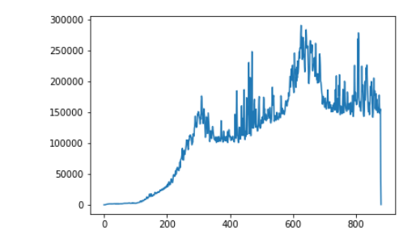

Figure 13: The trend of the time series data

Since the trend is almost monotonically increasing as observed from the graph in previous graph, the last value can be assumed as some sort of outlier (as seen by the dip in the graph at the end). Therefore, the last value along with first 3 values with zero general_power_supply is removed to make sure all general_power_supply values are non-zeroes. Plot after removing outliers and zero valued general_power_supply as shown below.

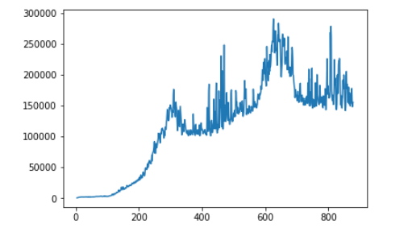

Figure 14: Result after removing outliers and zero valued

Converts time-series data to the supervised data format, with 10 prior time steps as input, and output is just a one-time step. In other words, we predict the next immediate value with the help of 10 prior values, and we prepare data in terms of that. Then dataset has been split into train and test that Contains the training dataset in list format which gets updated for every iteration. Then refitting XGboost based on the updated training dataset and predict the testing instance.

First Scenario:

Training initially with 465 (865-400) data instances. The MAPE: 0.074360

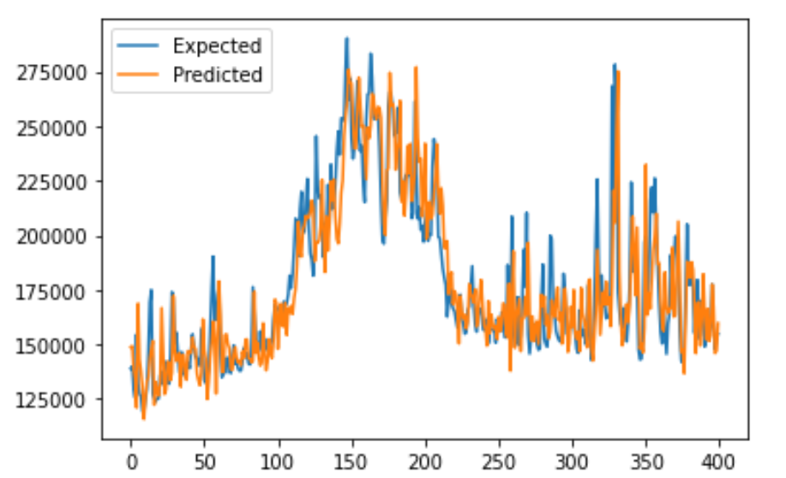

Figure 15: First Scenario

Second Scenario:

Training initially with 565 (865-300) data instances. The MAPE: 0.077

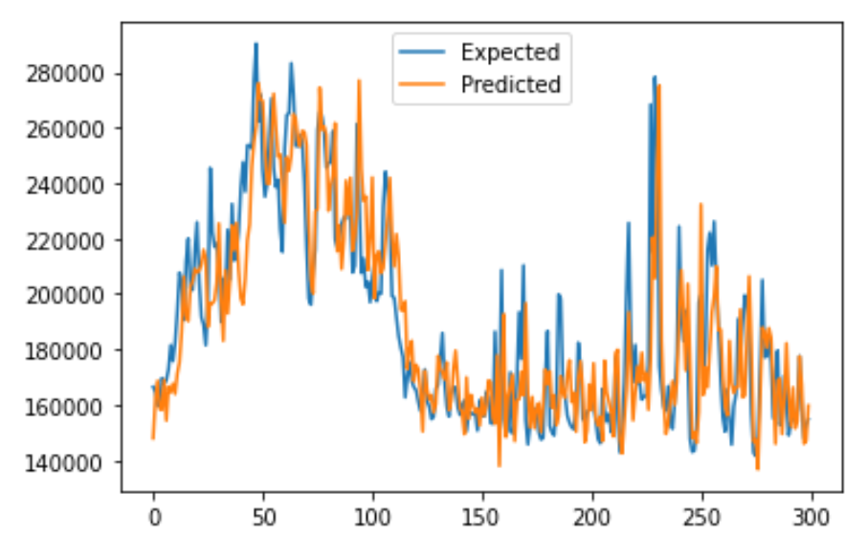

Figure 16: Second Scenario

Third Scenario:

Training initially with 665 (865-200) data instances. The MAPE: 0.078

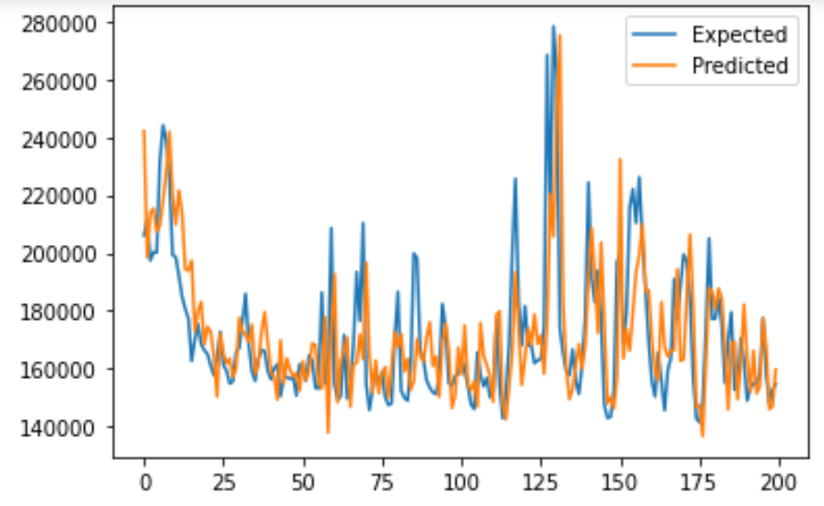

Figure 17: Third Scenario

We can see that in the three different scenarios with varied number of training instances (465, 565, and 665) used to train the model, the model gives an average MAPE of approximately 7.63%, which is in acceptable range.

We print the prediction of the model trained on 465 instances (First scenario). The test set size here is 400.

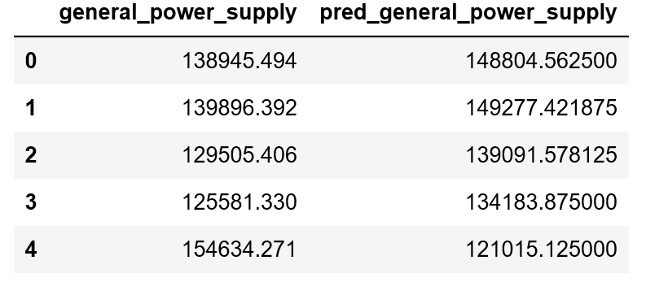

Table 6: The prediction of general power supply

## **Dashboard**

**Wind Power Dashboard Part 1**

https://snapshot.raintank.io/dashboard/snapshot/vl1HqQAw4Owf1u5VrlLVcli1fZYavExX

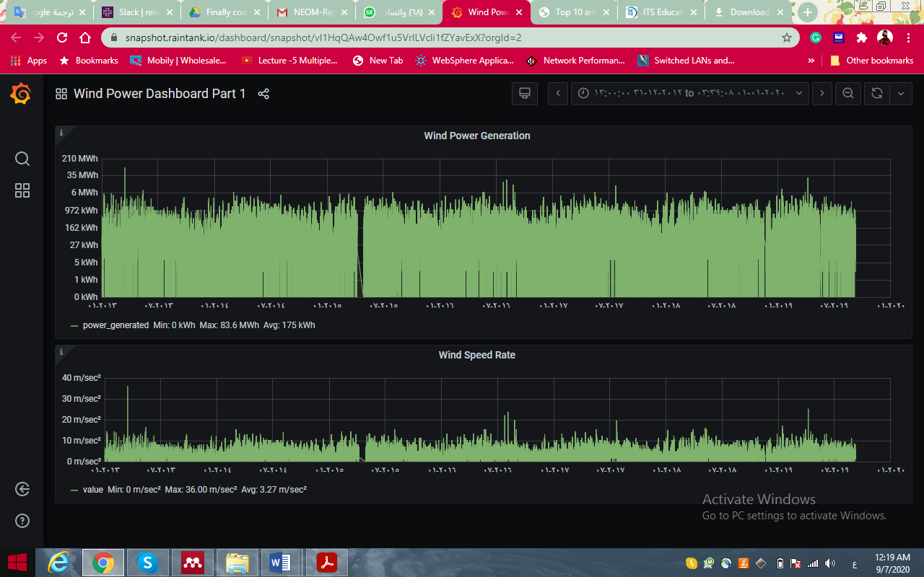

**Wind Power Dashboard Part 2 - Sky Ceiling Height**

https://snapshot.raintank.io/dashboard/snapshot/KUcAhn29MSTQJiFIMzPD3MQW6JJaX333?viewPanel=6&orgId=2

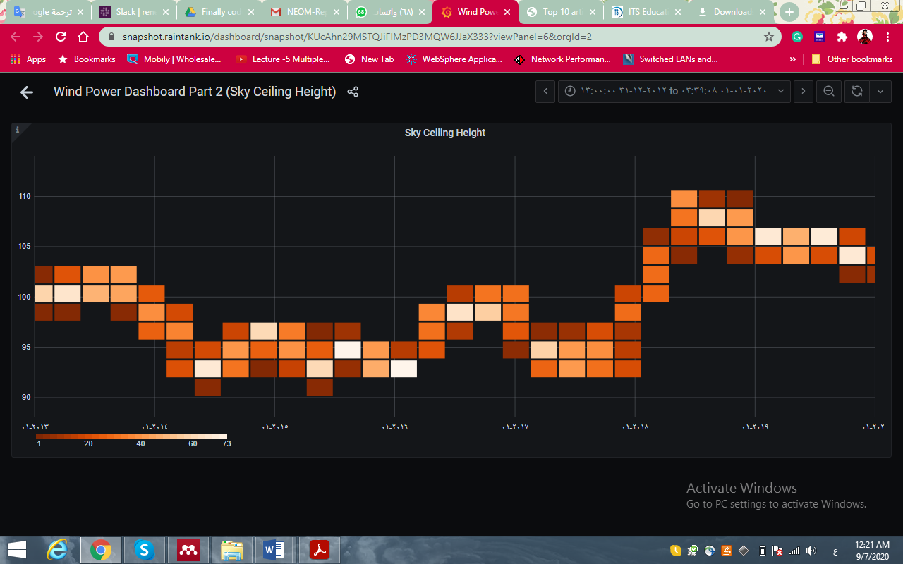

**Air Temperature**

https://snapshot.raintank.io/dashboard/snapshot/TnVvKVzvX1JO7m99cA20o62RZOd5qCwR?viewPanel=8&orgId=2

**Wind Power Dashboard Part 3 - Visibility Distance**

https://snapshot.raintank.io/dashboard/snapshot/nCr8pFubLU5QtKKSLE7fIsHMhS4pGzDD?viewPanel=7&orgId=2

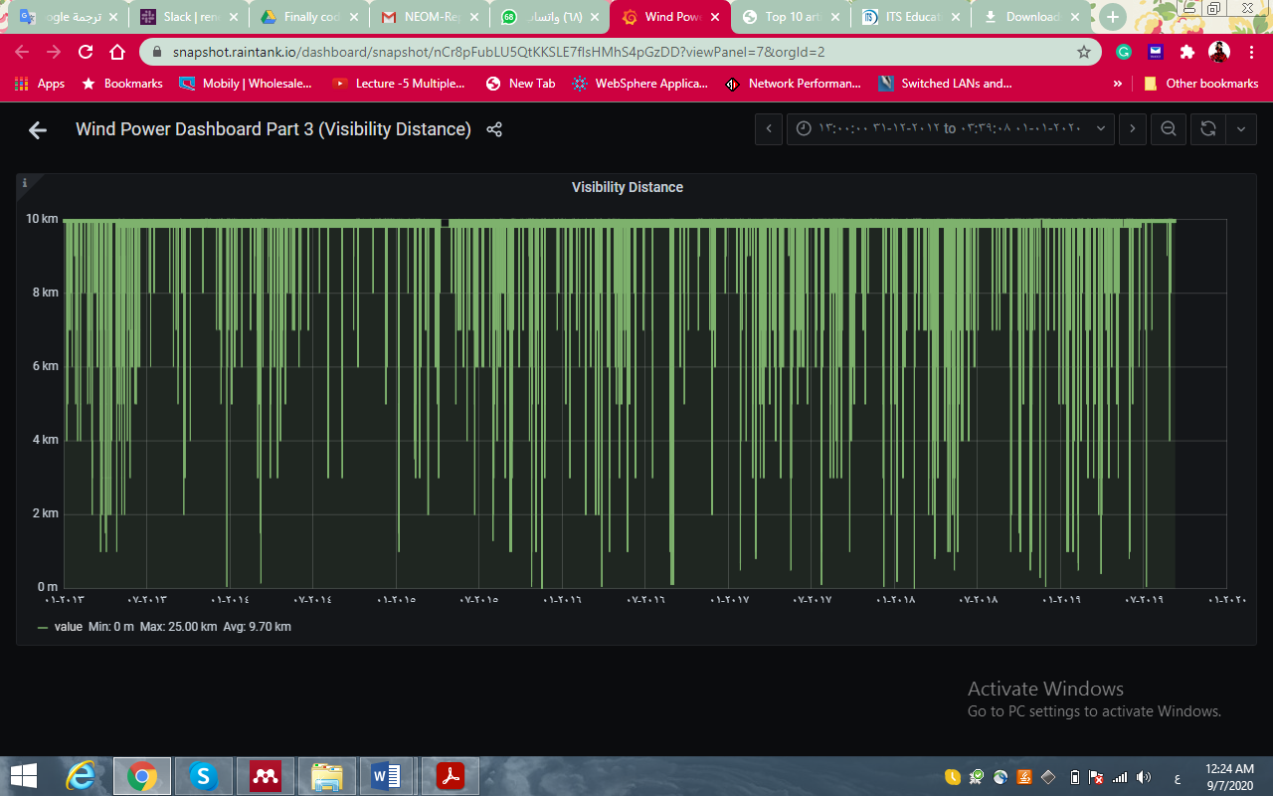

**Atmospheric Pressure**

https://snapshot.raintank.io/dashboard/snapshot/ekY53pI54AsiPgZm7P8BARKXbVAMmBNh?viewPanel=10&orgId=2

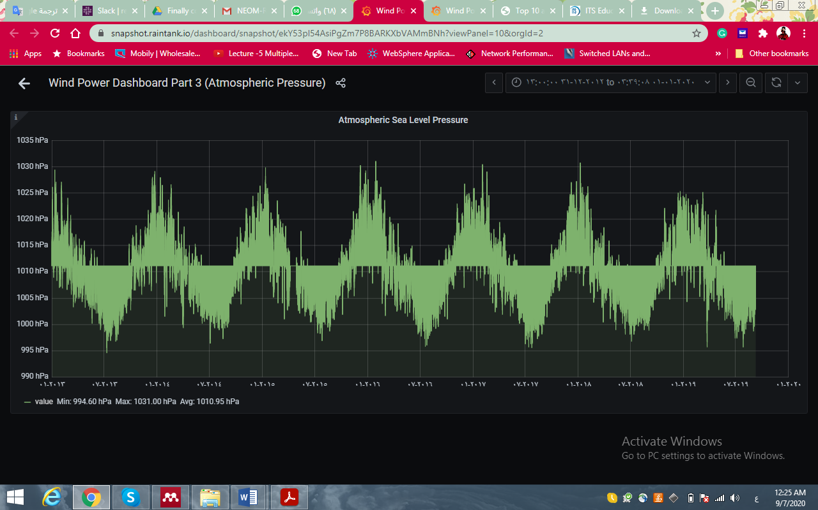

**Wind Power Dashboard Part 4 – Elevation**

https://snapshot.raintank.io/dashboard/snapshot/N0QJyRa7wZoNZeXE…

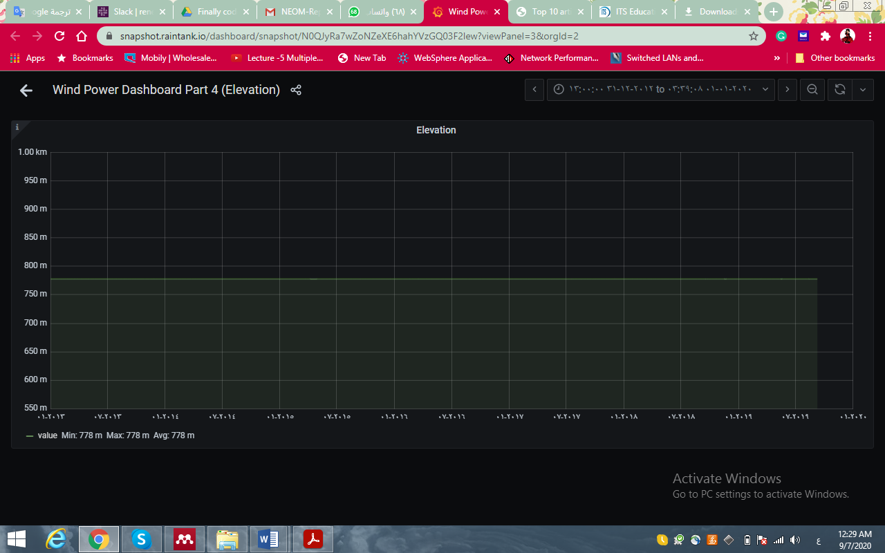

**Air Temperature Dew Point**

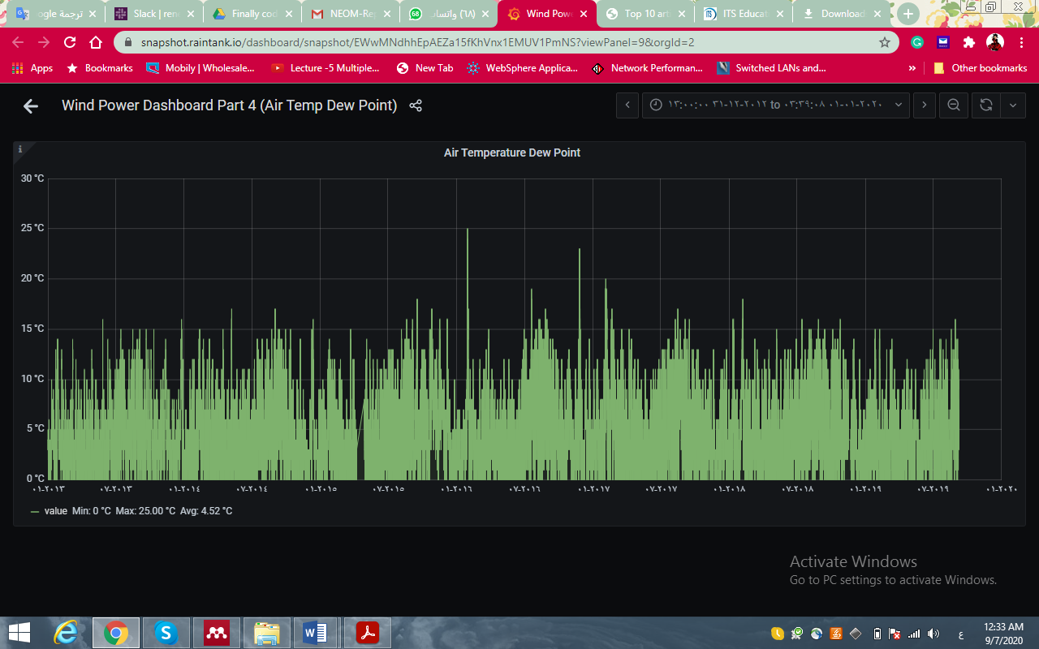

Wind Power Dashboard Part 5 - Wind Direction Angle

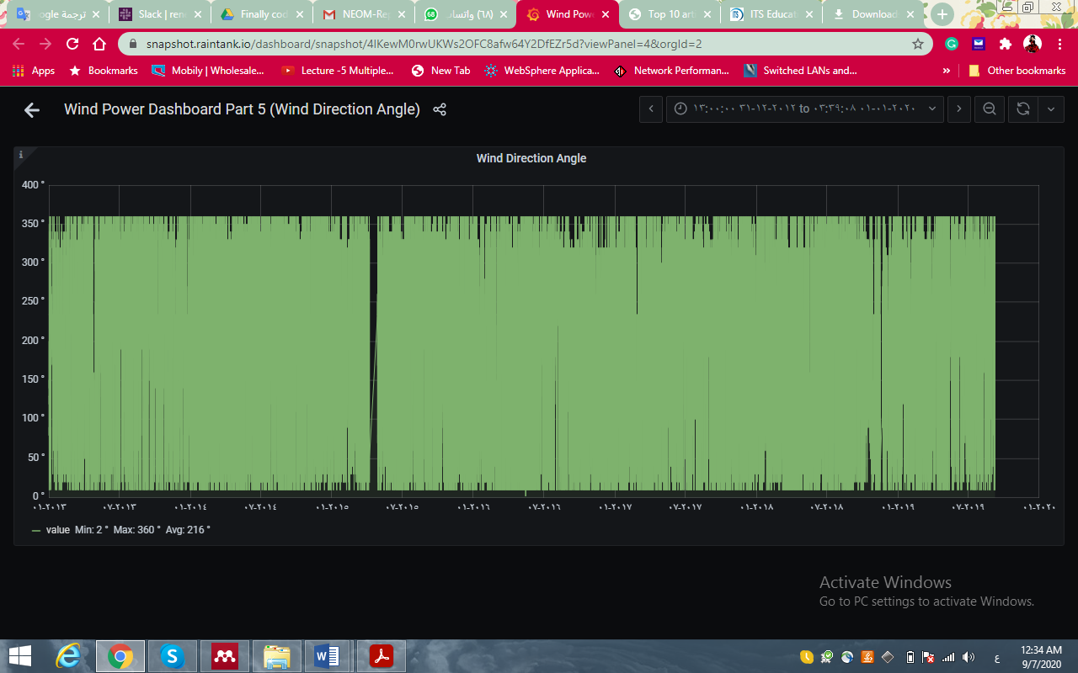

Air Density

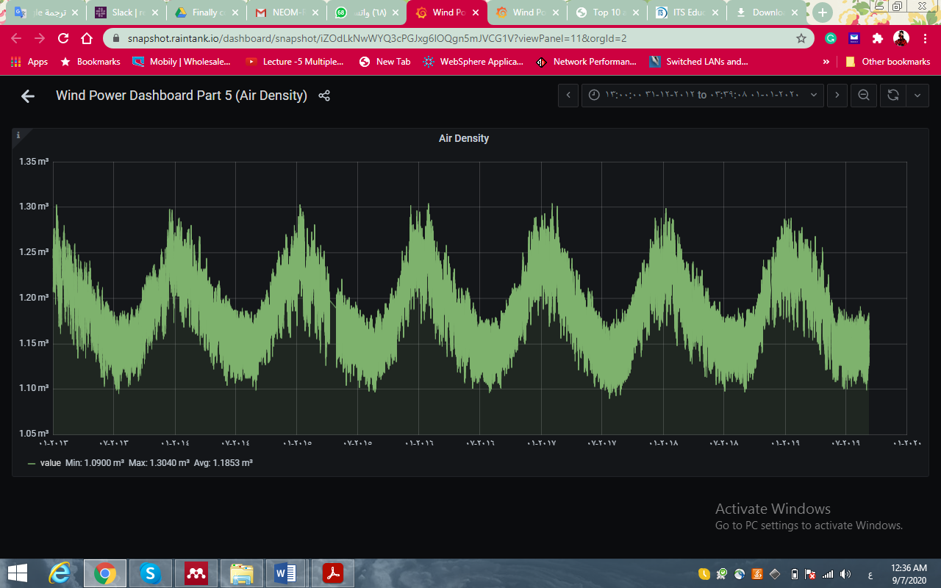

**Consumption Dashboard**

https://snapshot.raintank.io/dashboard/snapshot/uyuY3AThS4jQbrTqNGEcSF5cOmGRr700

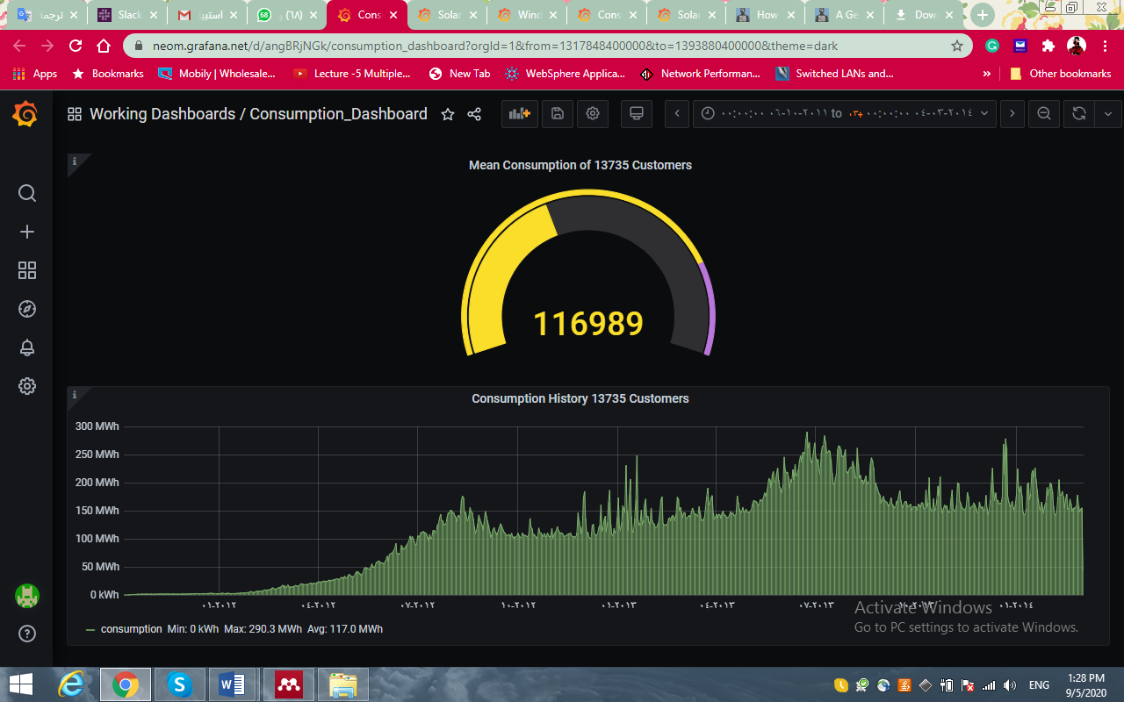

**Solar Power Dashboard** https://snapshot.raintank.io/dashboard/snapshot/346L4vVJCtJXmIjTWIU3nlxH6HsFlSci

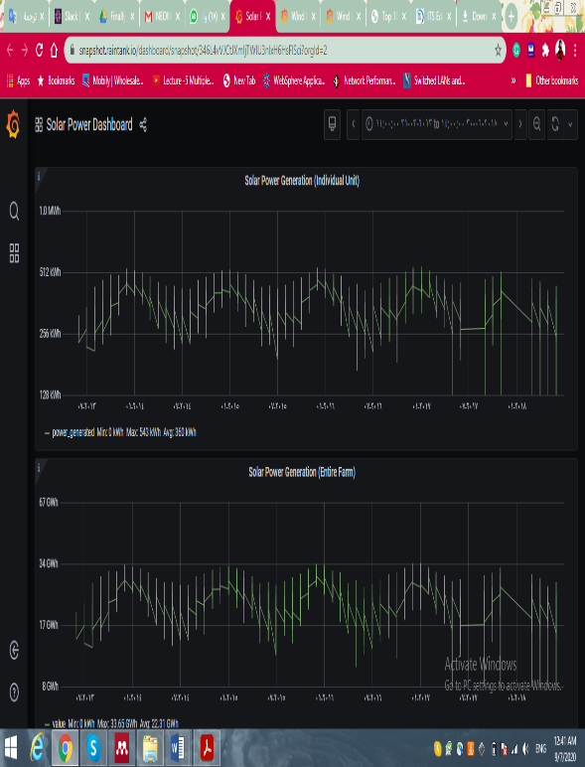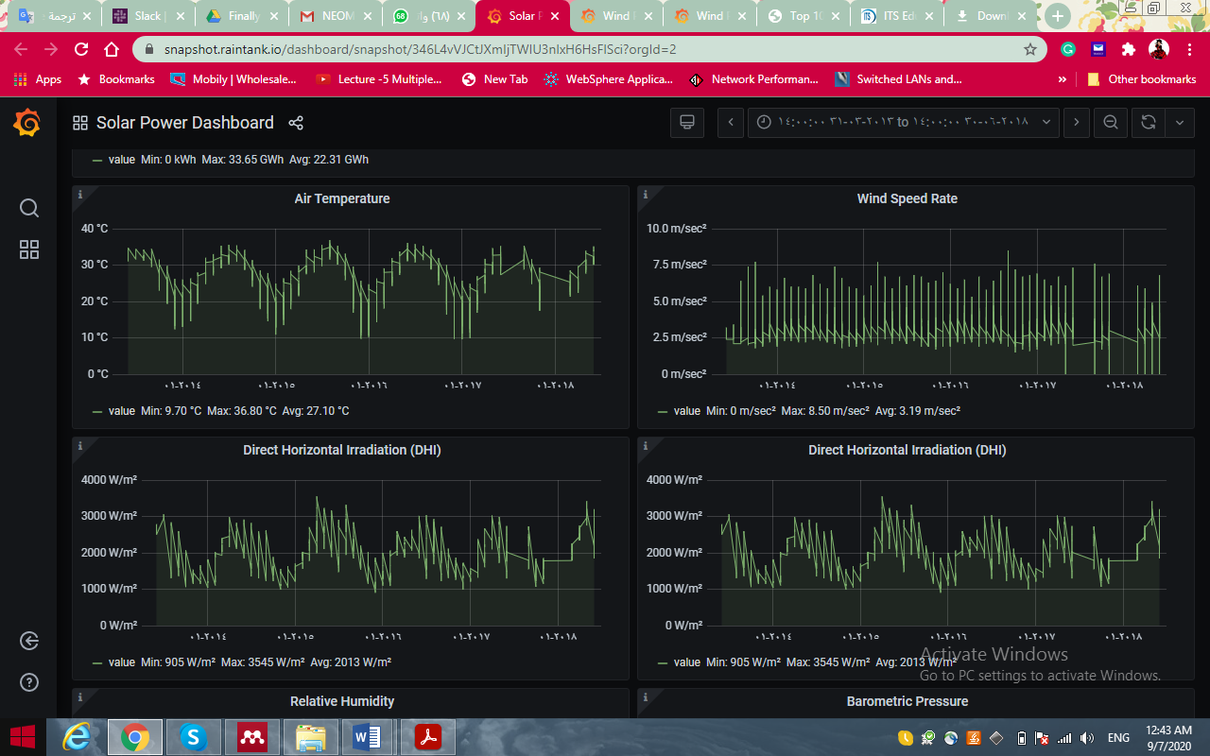

**Actual Consumption V.s predicted**

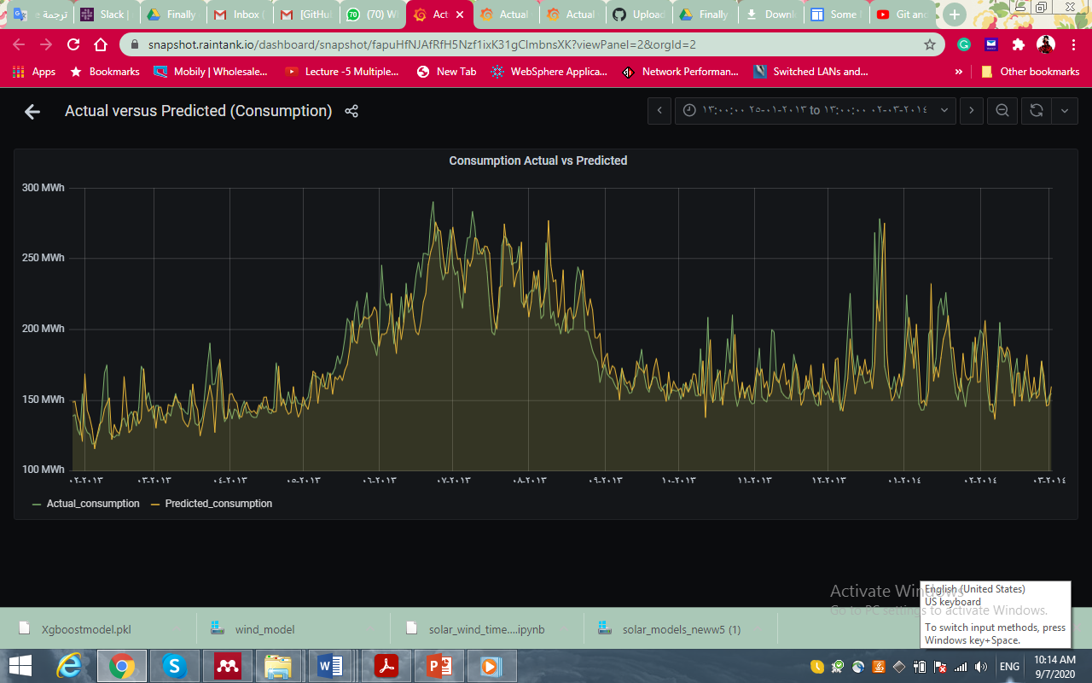

https://snapshot.raintank.io/dashboard/snapshot/Yi4DpLzVvWTukiQ26AwnIkqEHryZ5IGY?viewPanel=3&orgId=2

**Solar Actual Vs. Predicted**

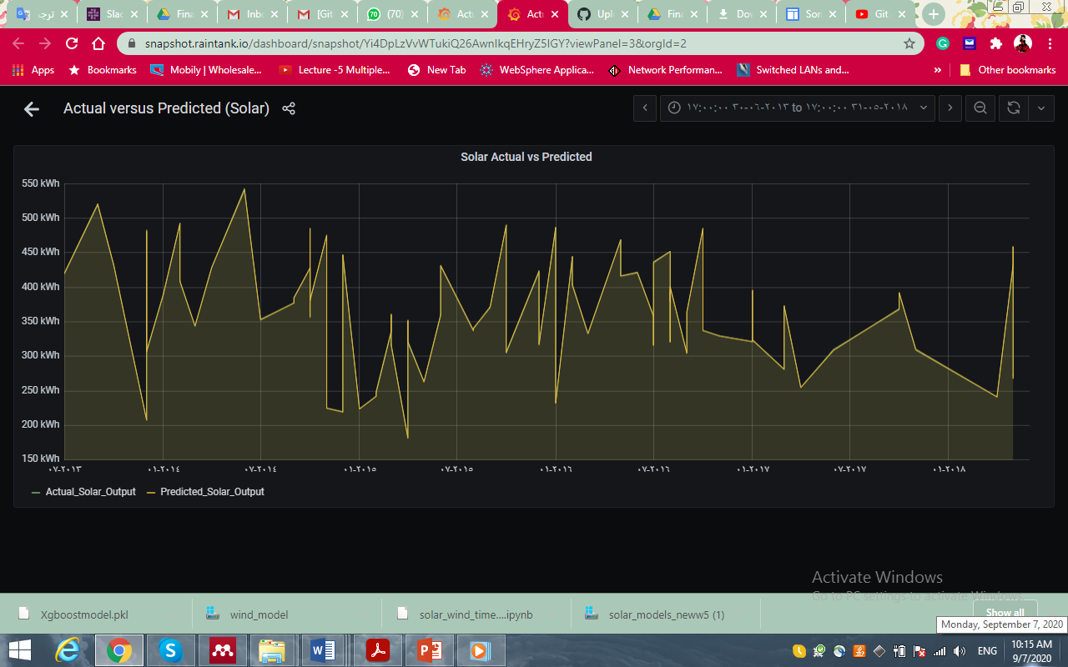

https://snapshot.raintank.io/dashboard/snapshot/fapuHfNJAfRfH5Nzf1ixK31gClmbnsXK?viewPanel=2&orgId=2

## **Application**





A prototype of applying AI to the NEOM historical data to predict renewable energy generation and consumption. This app is not official nor related to NEOM, it was built for the NEOM challenge purpose only.

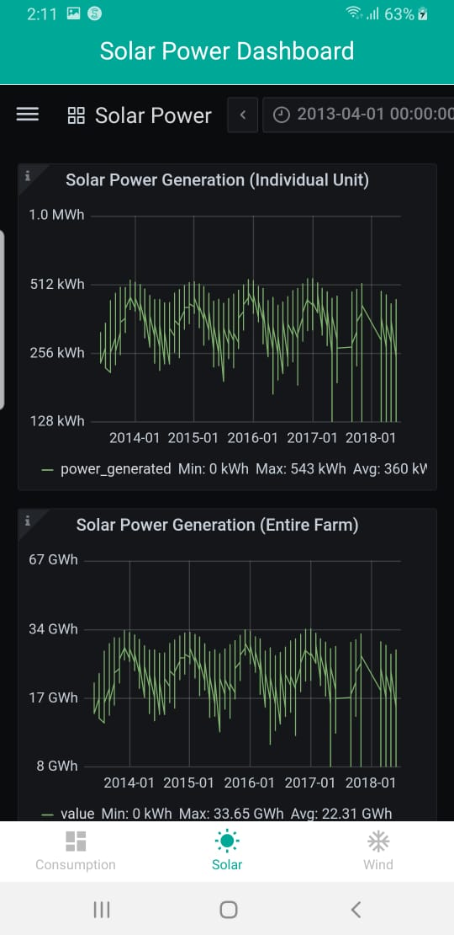

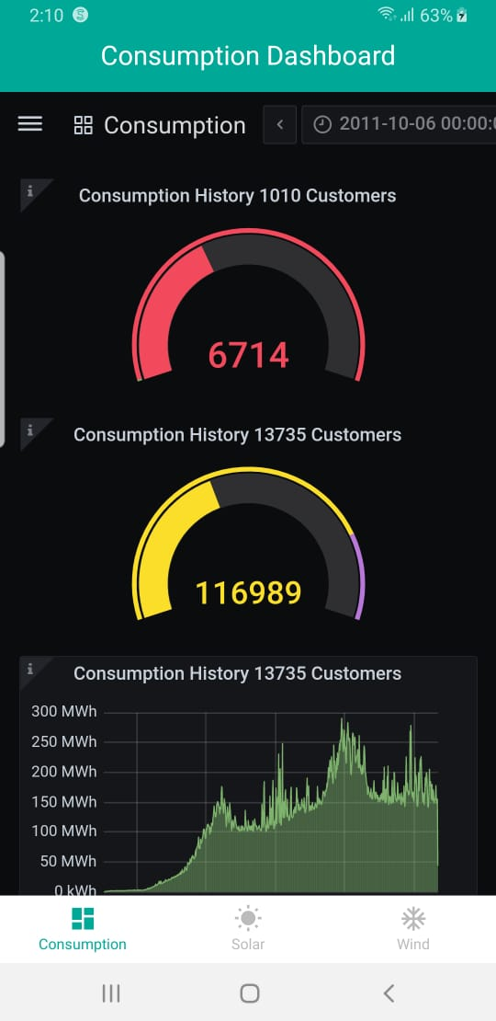

# SIGNIFICANCE

In our model, Artificial Intelligence (AI) and Deep Learning (DL) had been used to make predictions about the demand and predict energy consumption among users at NEOM. Through using Artificial intelligence (AI) we can evaluate the past, improve the present, and forecast the future. AI can improve the reliability of solar and wind power by analyzing huge amounts of real meteorological data and using this information to make predictions and decisions about when to gather, store, and distribute wind or solar power. So, the outcomes can be used to predict the energy production in the future thus basically reducing the cost. Moreover, our project paves the path to sustainable renewable energy. We achieve this by using AI to predict the future generation of power from different sources of energy to meet the demands of the consumers in NEOM city and also foreseeing what the future demands of energy would be.

By using AI our solution gives more accurate results and reduce the mean absolute percentage error (MAPE) to help in controlling the consumption and generation of renewable energy to contribute to one of the NEOM project aims; which is the establishment of industries that curb economic leakage in the Kingdom and the region in general.

RISK & OBSTACLES

**Data obtained and storage**

Our Model depends on sensor data in renewable resources as an input. Where a huge number of sensor data is collected for validation. So, the obstruction and crippling could happen because of noisy and incorrect datasets as will be hard to analyze and store. The solution will fail when no high-quality data is entered into it.

**Issues of management and responsibility**

The implementation comes with responsibility if any sort of hardware malfunctions any specific individual must bear the burden of it. Issues such as data breach can be a consequence of weak data governance which may slip into the hands of hackers. Also, no AI model is 100% percent accurate. Therefore, it would require a bit of human oversight before it is used for practical purposes.

**Computation speed**

Our Model requires a high degree of computation speeds offered only by high-end processors and needs a large infrastructure. Accordingly, the size of data obtainable for processing grows exponentially, the computation speed requirements will increase with it.

**Weather fluctuation**

The AI model relies basically on factors affecting weather to provide a solution. Therefore, outlier events such as blackouts or technical faults will not be considered.

# Related Work

|  |  |  |
| --- | --- | --- |
| Title | AI Approach | Limitation |
| (Laroui et al. 2019) | Deep learning | Energy management of EV in Smart Cities is ignored. |
| (Marzband, Azarinejadian, and ... 2015) | Artificial bee colony | Emission cost of a dis-patchable micro-turbine is not considered. Complex formulation. |
| (Arcos-Aviles et al. 2017) | Artificial Intelligence  (Fuzzy logic) | Battery degradation is not considered. Only the battery charger/grid-connected inverter is controllable. |
| (Kumar and Saravanan 2019) | Artificial fish swarm  optimization | Battery decline cost is not considered. |
| (Nwulu and Xia 2017) | AI Game theory | Emission cost of traditional generators is not considered |
| (Mondal et al. 2018) | AI Game theory | Computational complexity is not mentioned. |
| (Shuai et al. 2019) | Mixed-integer nonlinear  programming (MINLP) | Battery lifetime prediction is ignored. |
| (Chaouachi et al. 2013) | Linear programming | High computational complexity.  Cost of battery decline is not  Considered |
| (Taha and Mohamed 2016) | No linear and mixed-integer programming | Power wasted and demand are not considered. |
| (Sukumar et al. 2017) | Linear and mixed-integer linear programming | Costs of battery reduction are not considered. |

Table 7: Previous Studies using AI approach

# CONCLUSION

Nowadays, the need for energy is at its highest and is projected to increase in the near future giving way to challenges such as increasing energy costs, environmental pollution, and limited reserves. This has led to renewable energy to be the most popular alternative to fossil fuels. Solar energy, wind energy, geothermal energy, and wave energy are renewable energy sources that are considered to be unlimited since they always renew themselves and exist naturally. Solar power predicting will have an important effect on the future of large-scale renewable energy plants. Forecasting photovoltaic (PV) power generation depends seriously on climate conditions as well as wind power, which fluctuate over time.

In our research, we propose a mix of renewable energy (solar and wind) at a low cost that reduces the negative impact on the environment. This project combines the prediction, consumption, and generation of energy by using Deep Learning (DL) and Artificial Neural Network (ANN). One of the main takeaways is that much care has been taken in selecting the source of data source matching the Saudi Weather conditions around the NEOM region. This will balance the power consumption and power generation to avoid waste of energy and will lead to an innovative energy solutions in NEOM.

Q & A

**Who is going to use our solution in NEOM?**

The system is meant to be used by City Administration officials. Specifically, it is to be utilized those in charge of maintaining the stable supply of electricity to NEOM on a regular basis.

**Why our solution can be implemented in NEOM?**

Our solution can be scaled to fit the realistic requirement of NEOM since the data sources are from reliable sources approximated as much as possible for the NEOM geographical area. As long as weather sensors collect data accurately in NEOM when implemented, our solution will be able to continuously provide utility.

**How we are implementing AI to solve the problem?**

The AI models used in this solution have been trained on highly accurate information and can be utilized to predict energy demands. The AI in our solution uses a combination of supervised and unsupervised machine learning techniques and Neural Network architecture to deliver the solution.

REFERENCES

Arcos-Aviles, Diego et al. 2017. “Low Complexity Energy Management Strategy for Grid Profile Smoothing of a Residential Grid-Connected Microgrid Using Generation and Demand Forecasting.” *Applied Energy*.

Brownlee, Jason. 2019. “How To Backtest Machine Learning Models for Time Series Forecasting.” *machinelearningmastery*. https://machinelearningmastery.com/backtest-machine-learning-models-time-series-forecasting/.

Chaouachi, Aymen, Rashad M. Kamel, Ridha Andoulsi, and Ken Nagasaka. 2013. “Multiobjective Intelligent Energy Management for a Microgrid.” *IEEE Transactions on Industrial Electronics*.

Jason Brownlee. 2020. “A Gentle Introduction to XGBoost for Applied Machine Learning.” *machinelearningmastery*. https://machinelearningmastery.com/gentle-introduction-xgboost-applied-machine-learning/.

Kadirgama, K., A. K. Amirruddin, and R. A. Bakar. 2014. “Estimation of Solar Radiation by Artificial Networks: East Coast Malaysia.” In *Energy Procedia*,.

Kalani, Hadi, Mohammad Sardarabadi, and Mohammad Passandideh-Fard. 2017. “Using Artificial Neural Network Models and Particle Swarm Optimization for Manner Prediction of a Photovoltaic Thermal Nanofluid Based Collector.” *Applied Thermal Engineering*.

Kumar, K. Prakash, and B. Saravanan. 2019. “Day Ahead Scheduling of Generation and Storage in a Microgrid Considering Demand Side Management.” *Journal of Energy Storage*.

Laroui, Mohammed et al. 2019. “Energy Management for Electric Vehicles in Smart Cities: A Deep Learning Approach.” In *2019 15th International Wireless Communications and Mobile Computing Conference, IWCMC 2019*,.

Marzband, M, F Azarinejadian, and ... 2015. “An Optimal Energy Management System for Islanded Microgrids Based on Multiperiod Artificial Bee Colony Combined with Markov Chain.” *IEEE Systems …*.

Mondal, Ayan et al. 2018. “DEMANDS: Distributed Energy Management Using Noncooperative Scheduling in Smart Grid.” *IEEE Systems Journal*.

Nwulu, Nnamdi I., and Xiaohua Xia. 2017. “Optimal Dispatch for a Microgrid Incorporating Renewables and Demand Response.” *Renewable Energy*.

Shuai, Hang et al. 2019. “Optimal Real-Time Operation Strategy for Microgrid: An ADP-Based Stochastic Nonlinear Optimization Approach.” *IEEE Transactions on Sustainable Energy*.

Sukumar, Shivashankar et al. 2017. “Mix-Mode Energy Management Strategy and Battery Sizing for Economic Operation of Grid-Tied Microgrid.” *Energy*.

T. Khatib, A. Mohamed, M. Mahmoud, K. Sopian. 2012. “Estimating Global Solar Energy Using Multilayer Perception Artificial Neural Network.” *International journal of energy* 6: 82–87.

Taha, Mohamed S., and Yasser A.R.I. Mohamed. 2016. “Robust MPC-Based Energy Management System of a Hybrid Energy Source for Remote Communities.” In *2016 IEEE Electrical Power and Energy Conference, EPEC 2016*,.